PRICES

Prices - one of the easiest ways to regulate sales of products. Price changes do not have big residual effect on sales. After returning to the original value of the price, sales restore to its original level.

**Test 1 - Scenario 12C1 - Product 1 (EU)**

Effect of price changes on sales is practically independent from average prices in the group. Vertically - relative change on sales compared with the previous period. Horizontally - absolute value of the price. All points lie on trend line. Dependence is not strictly directly proportional, because elasticity slightly decreases while price increases.

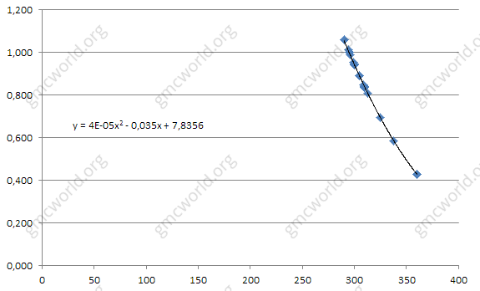

If you do not take in calculation extreme points, for convenience of calculation we can assume that elasticity as directly proportional.

**Test 2 - Scenario 12C1 - Product 3 (EU)**

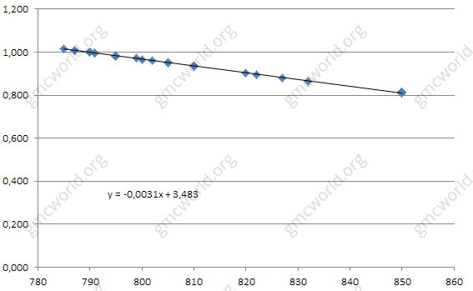

Elasticity of prices is different for each market and product type.

**Test 3 - Scenario 12C3 - Product 1 (EU)**

Price elasticity for scenario 12C3 is very different from scenario 12C1. Points still lie on trend, which indicates that there is no significant influence of the competitors in the group.

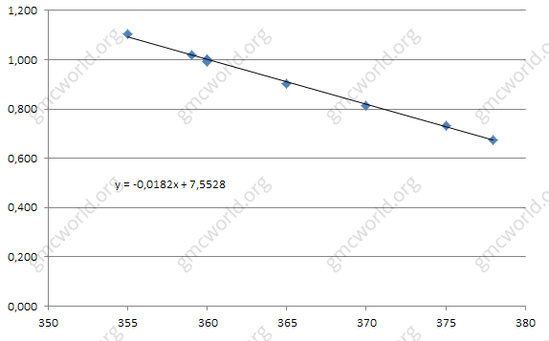

**Test 4 - Scenario 12C3 - Product 1 (EU and Nafta)**

Price elasticity for Product 1 in both markets EU and Nafta looks equal, coefficient is -0.0177. Price elasticity for Products 2 and 3 have a slight difference, so we can assume that elasticity in EU and Nafta on scenario 12C3 are the same.

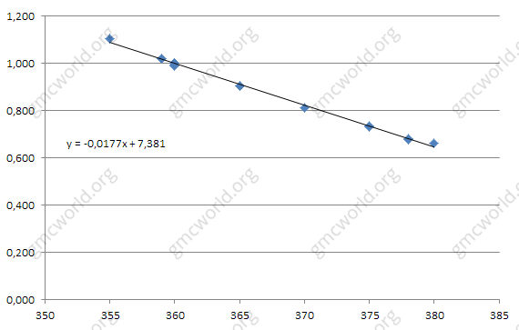

Optimal strategy is setting prices according to the required load and production plan. Prices are not a stimulating factor for demand in pure form and should be used for balancing production.

**Dependence of price elasticity on market load**

With total shares of companies increasing in the group to 100%, price elasticity decreases proportionally to 0%. Total shares in current period affect on price elasticity in current period. To forecast sales properly you should plan market load. That means each period is necessary to recalculate the price elasticity while you forecast market load.

**Hints**

1．No residual effect

2．Dependence directly proportional

3．The effect is different in markets and products

4．Price elasticity is directly proportional to market load

价格

价格－调节产品销售的最简单的方法之一。 格变动对销售没有大的剩余影响。回到原价后，销售恢复到原来的水平。

**测试1 - 情景12C1 - 产品1（国内）**

价格变动对销售的影响几乎与小组平均价格无关。与上期相比，销售额呈现垂直相对变化。 水平－价格的绝对价值。所有点都位于趋势线上。依赖性并不是严格的直接成比例的，因为价格上涨时弹性略有下降。



如果不计算极值点，为了方便计算，我们可以认为弹性是直接成比例的。

**测试2 - 情景12C1 - 产品3（国内）**



价格弹性对于每个市场和产品类型都是不同的。

**测试3 - 情景12C3 - 产品1（国内）**

情景12C3的价格弹性与情景12C1非常不同。 积分依然趋于趋势，这表明竞争对手在该集团中没有显着影响。



**测试4 - 情景12C3 - 产品1（国内和北美）**

国内和北美两个市场产品1的价格弹性看起来相当，系数为-0.0177。 产品2和3的价格弹性略有不同，所以我们可以假设情景12C3中国内和北美的弹性是相同的。



最优策略是根据所需的负荷和生产计划设定价格。价格不是纯粹形式的需求的刺激因素，应该被用于平衡生产。

**价格弹性对市场负荷的依赖**

随着公司股份总数增加到100%，价格弹性按比例下降到0%，本期股份总数影响当期价格弹性。 要正确预测销售情况，您应该计划市场负担。 这意味着每个期间都需要重新计算价格弹性，同时预测市场负荷。

**提示**

1．无残留效应

2．直接成比例依赖

3．对各市场和产品的影响是不同的

4．价格弹性与市场负荷成正比